Jaden Williams

SNHU – CS330

4/20/25

Final Project Design Decisions

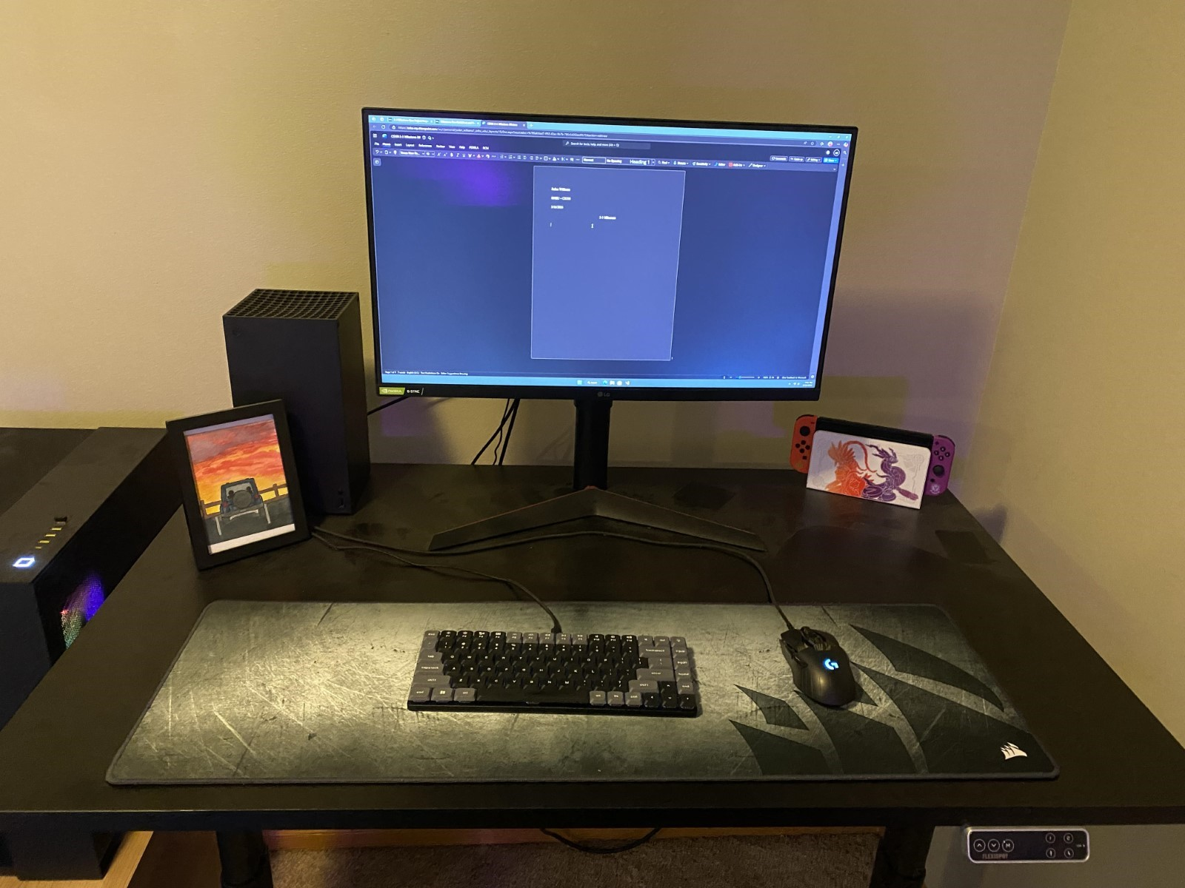  
For my final project, I chose to recreate something familiar to me, my desk. I was fairly ambitious with wanting to recreate the keyboard, mouse, and Nintendo Switch but I ended up cutting those from the project as they became too time consuming. The monitor itself was my complex object. It required a lot of fine tuning with transformations, scaling, textures and lighting but I feel I ended up in a decently faithful recreation of it.

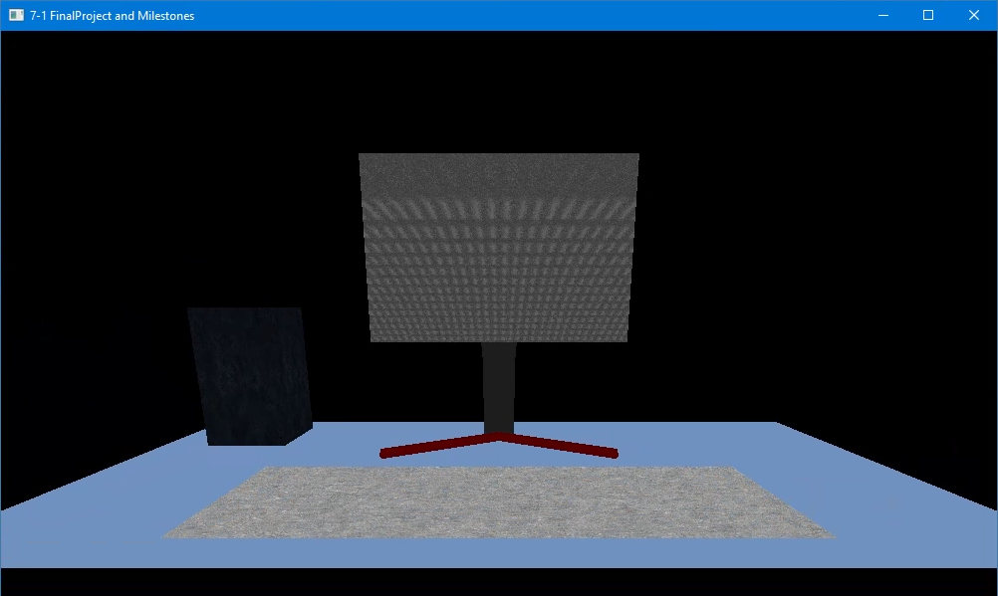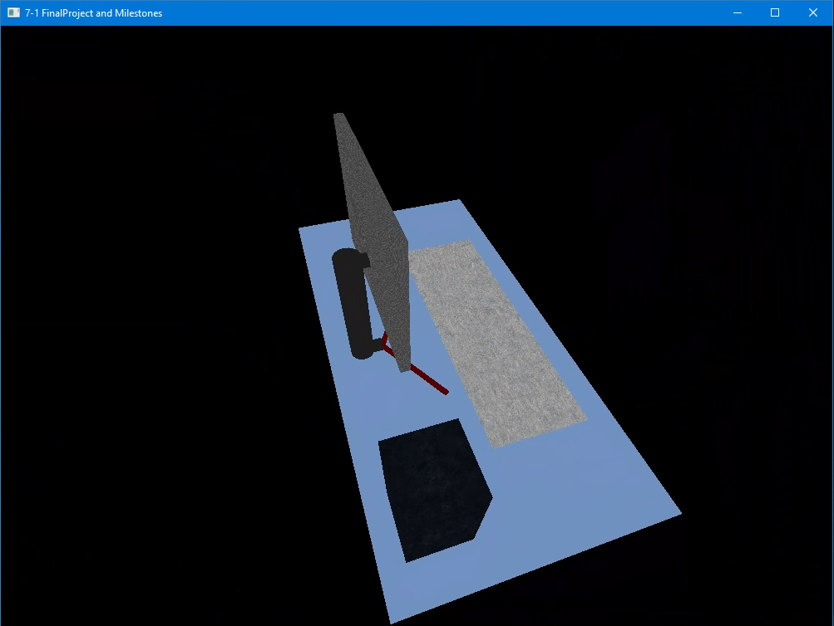

I decided to switch up the colors of my scene as I felt I had way too much black and gray going on. To make it visually more diverse I went with a light blue texture for the plane that is my desk surface and made the monitors legs a maroon texture.

Navigation:

The user can navigate my scene through keyboard and mouse as the primary input methods. The mouse pans the camera in all directions, while using the WASD keys moves the camera forward, backward and side to side. The Q and E keys raise and lower the camera to fine-tune the height of the camera. The O and P keys give Orthographic and Perspective views of the scene as well. When using the mouse scroll wheel, the user can adjust the speed at which the camera is able to move around the scene, adjusting from nearly a stand-still to moving arond the scene very quickly.

Custom Functions:

In the first milestone for the project, we were given an easy-to-read layout of how to create the mesh for a plane. I decided to format each of the functions I created for the scene in this same way, so that any outside person could look at the code and understand what I was doing (Or attempting to do). When I had to implement the functions for the lighting it was a real challenge for me, I did not honestly think I was going to accomplish it. Looking at the assignment for lighting a pre-made scene I was able to recreate the code from there and implement it. Through learning from a pre-made function I now feel comfortable re-using it throughout my scene to get the best-looking lighting I can for each of my objects.